Game Design Document

Fill up the following document

1. Write the title of your project.

Zombie Shooter

2. What is the goal of the game?

Our MC has to defeat the zombies or be defeated himself

3. Write a brief story of your game.

The world is infested with zombies and a lone survivor has to save the world by defeating the zombies… or DIE trying.

4. Which are the playing characters of this game?

● Playing characters are the ones who respond to the user based on the input from the user.

● Cars, monkeys, dinos, wizards, etc., are the playing characters in the game.

|  |  |  |
| --- | --- | --- |
| Number | Character Name | What can this character do? |
| 1 | Our MC(the shooter) | Shoot the zombies |
| 2 |  |  |
| 3 |  |  |
| 4 |  |  |
| 5 |  |  |
| 6 |  |  |
| 7 |  |  |
| 8 |  |  |

5.

6. Which are the Non-Playing Characters of this game?

● Non-Playing characters are the ones that don't have an action or behavior when the user interacts with the game.

● Hurdles, stones, bananas, coins, etc., are non-playing characters in the game.

|  |  |  |
| --- | --- | --- |
| Number | Character Name | What can this character do? |
| 1 | Zombies(BILLIONS of them) | Infest the world, kill our shooter, etc |
| 2 |  |  |
| 3 |  |  |
| 4 |  |  |
| 5 |  |  |
| 6 |  |  |
| 7 |  |  |
| 8 |  |  |

Draw your imagination of this game. What does this game look like?

● Draw the game either on your computer or on paper.

● Add images of the game scenes to show each of the playing and non-playing characters at least once.

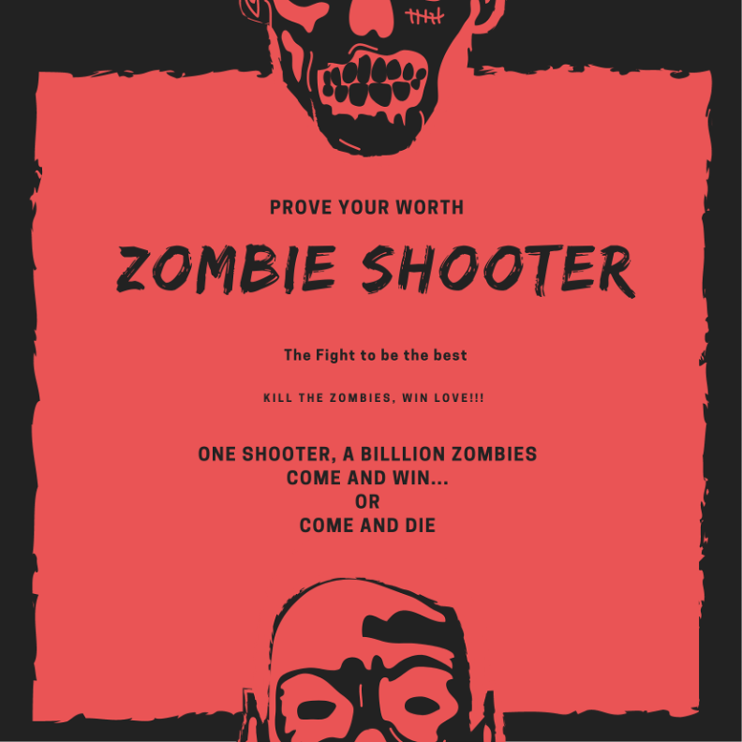

How do you plan to make your game engaging?

Ans: There will be three lives that our MC has and each time a zombie kills him, he will be reborn, but only twice. He needs to kill all the zombies before the sun comes up and there will also be a scoring system plus a limited number of bullets so that getting a gun doesn’t go to his head.